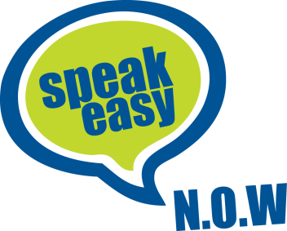
Equal Opportunities Monitoring Form
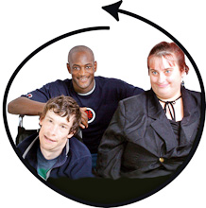
At Speakeasy N.O.W. we want to make sure that we include as many people as possible in our work.
We want to have members, staff and volunteers from lots of different backgrounds.
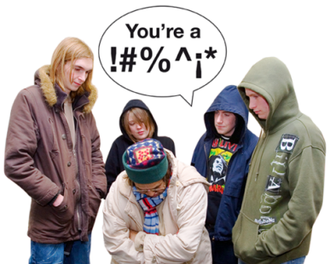
We want to make sure that no one is treated badly or made to feel bad because of their gender, sexual orientation, age, religion, race, nationality, ethnic origins or disability.
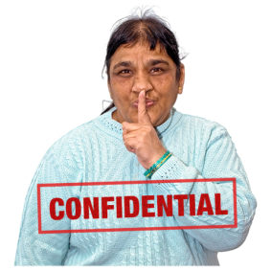
The information on this form will be used to help us to do this. We will not show your answers to anyone else and no one will know that you have filled in this form.

Please tick the box that applies to you.
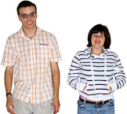
Gender
Male Female

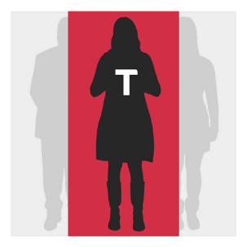
Do you identify as transgender?

Yes No

Prefer not to say
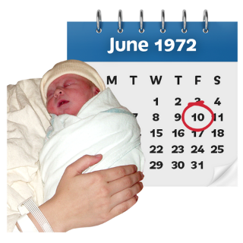
Please tell us your date of birth?
………………………………………………………………...

I prefer not to say

Ethnic Origin

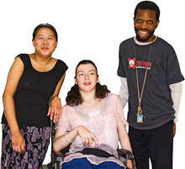
White
Mixed
Asian/Asian British
Black/black British
Chinese/ Other

Disability
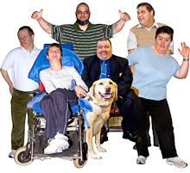
Do you consider yourself to have a disability?

Yes No
If yes, please tell us what your disability is?
……………………………………………………………..
If you live in the Worcestershire, which area of the county do you live in?

Bromsgrove
Malvern
Redditch
Worcester
Wychavon
Wyre Forest

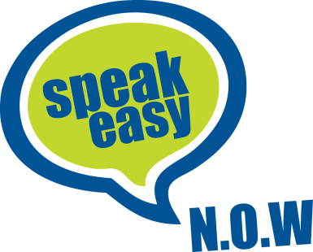
Are you a member of Speakeasy N.O.W.?

Yes No

Thank you for your time. Please return the form with your application.

